Raising Yellow, Pushing Up Blue rev1a (Movie: https://youtu.be/fKZGZK5Ackk )
Sequential Photos of the ATD Functioning during Test
Test Model: 3-Stage, Folding Anti-Tsunami Door (ATD)
Total ATD Height: 1.3 m (0.5 m when folded) ； Generated wave height: 1.0 m
Place: O. H. Hinsdale Wave Research Laboratory (Large Wave Flume) in Oregon State University
Date: March 23, 2022

1. Just before the wave arrived, the ATD was fully folded. The back of the 2nd stage (yellow) of the ATD is visible. | 4. The erect ATD continued to retard the advancing wave. [time: 1.3 seconds]
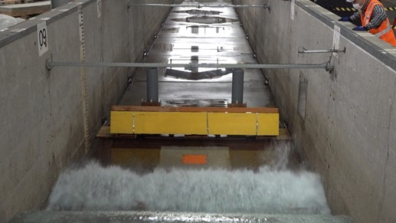 | 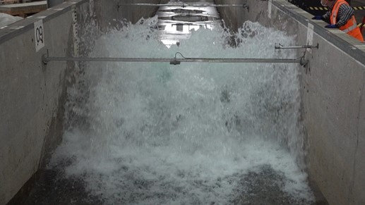
2. When the wave hit, the ATD started to unfold. [time: 0.4 seconds] | 5. After the wave started to recede, the top of the erect ATD became visible. [time: 2.3 seconds]
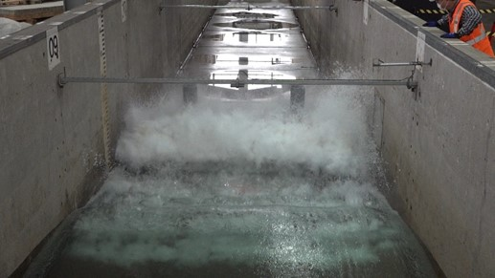 | 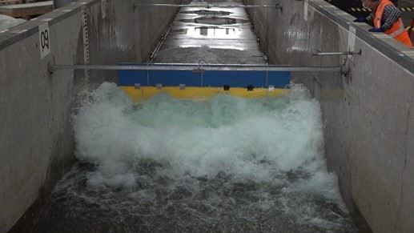
3. The ATD is fully unfolded and erect. [time: 1.1 seconds] | 6. After the wave receded, the erect ATD became fully visible. The front of the 3rd stage (blue) and the 2nd stage (yellow) are visible. [time: 6.4 seconds]
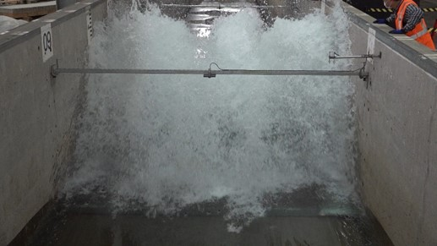 | 